Mass Velocity Time Momentum
Power kinetic energy Displacement Weight
(a) Choose the vector quantities from the box above.
………………………………………………………………………………………………
………………………………………………………………………………………...…. [2]

(b) A student goes to two weighing machines and tries to find out his mass. He steps on each weighing scale twice just to confirm the readings. Below is a table showing the values from the two different weighing machines. The mass is given in kilograms.

Scale | Trial 1 | Trial 2
A | 66 kg | 67 kg
B | 79.0 kg | 78.7 kg

If the actual mass of the student is 65.5 kg comment on the accuracy and precision of both weighing machines.

Accuracy ………………………………………………………………………………………………………………………………………………………………………………………………………………………………………………………………………………………………

Precision ………………………………………………………………………………………………………………………………………………………………………………………………………………………………………………………………………………………...…[4]

(iii) By finding the average mass, calculate the % uncertainty of the mass measurements taken using scale B, given the absolute uncertainty of Scale B is ± 0.1kg.

uncertainty = ………………….… % [2]

- An aircraft accelerates horizontally from rest and takes off when its speed is 82 ms⁻¹. The mass of the aircraft is 5.6 × 10⁴ kg and its engines provide a constant thrust of 1.9 × 10⁵ N.

(a) Calculate
(i) the initial acceleration of the aircraft

acceleration = ……….…….…… ms⁻² [2]

(ii) the minimum length of runway required, assuming the acceleration is constant.

length = …………..……… m [2]

(b) In practice, the acceleration is unlikely to be constant. State a reason for this and
explain what effect will this have on the minimum length of runway required.

............................................................................................................................................
............................................................................................................................................
............................................................................................................................................
...........................................................................................................................................[2]

3 Figure 3.1 shows a vertical force, F, being applied to raise a wheelbarrow which has a total weight of 500 N.
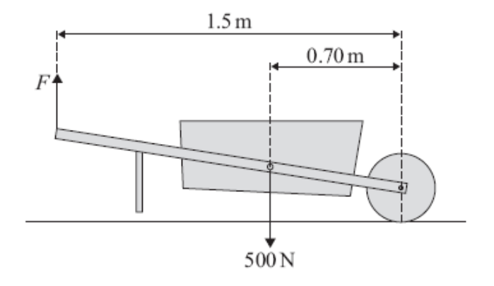

Figure 3.1

(a) On Figure 3.1 draw an arrow to represent R, the force exerted by the ground on the wheel. [1]

(b) Calculate the minimum value of the vertical force, F, needed to raise the legs of the wheelbarrow off the ground.

force = ………………….. N [2]

(c) Calculate the magnitude of R when the legs of the wheelbarrow have just left the ground.

R = ………………………. N [2]

- A steady stream of water strikes a wall horizontally without rebounding and, as a result, exerts a force on the vertical wall. Water arrives at the wall at a rate of 18 kgs⁻¹. It strikes the wall horizontally, at a speed of 7.2 ms⁻¹ without rebounding.
(a) Calculate
(i) the change in momentum of the water in one second

change in momentum = ………………….. kgms⁻¹ [2]

(ii) the force exerted by the water on the wall.

force = ……………….. N [2]

(b) State and explain the effect on the magnitude of the force if the water rebounds after striking the wall.
…………………………………………………………………………………………………………………………………………………………………………………………………………………………………………………………………………………………………………………………………………………………………………………[2]

- (a) Distinguish between the structure of crystalline and non-crystalline solids, making reference to appropriate examples.

………………………………………………………………………….……….……....
…………………………………………………………………………..….….….…….
………………………………………………………………………….…..….………..
……………………………………………………………………………………..….[4]

(b) Define the terms stress and strain as applied to a wire being stretched.

….………………………………………………………………………….…………….
….……………………………………………………………………….……………….
………………………………………………………………………………..……….[2]

(c) A wire, made of a ductile material of density 7.6 × 10³ kg m⁻³, has an area of cross section 2.5 × 10⁻⁷ m² and initial length 2.00 m. It is stretched by applying a tensile force to it. The force increases to 48 N, at which value the extension increases from 8.0 mm to 88 mm, as shown in the figure below. Once the extension has reached 88 mm the force is removed and the wire is then seen to have been permanently stretched by 80 mm.
F/N
48
8
88
0
extension/mm
80

Calculate the
(i) mass of the wire,

mass = ……………………. kg [2]

(ii) strain in the wire when the extension is 8.0 mm,

strain = ……………………… [2]
(iii) work done on the wire
1. while the extension increases from zero to 8.0 mm,

work done = ………………….. J
2. while the extension increases from 8.0 mm to 88 mm.

work done = ………………….J [4]

(iv) For part (ii) and (iii), state the energy transformation for the work done respectively.
…………………….…………………………………………………………….
………………….....………………………………………………………….[2]

6 (a) (i) State what is meant by the diffraction of a wave.

…………………………………………………………………………………….
…………………………………………………………………………………[2]
(ii) The diagram of Figure 6.1 and Figure 6.2 represent plane wavefronts approaching a wide gap and a narrow gap respectively.
Wide Gap
Fig 6.2
Narrow Gap
Fig 6.1

Draw on each diagram lines, illustrating diffraction, to represent the wavefronts after passing through the gaps. [3]

(b) Parallel monochromatic light is incident normally on a diffraction grating having 3.0 × 10⁵ lines per meter. A meter rule positioned 2.00 m from the grating and parallel to its plane is shown below.
Monochromatic light

Grating

81.0 cm

45.0 cm

9.0cm
2.00 m
Fig 6.3

The axis of the rule is normal to the lines of the grating. Bright lines are observed on the rule at the 9.0 cm, 45.0 cm and 81.0 cm marks. Calculate the wavelength of the light.

wavelength = …….……………….. m [2]

7
R
E₁= 20V
E₂= 12V
+
_

A generator of e.m.f. 20 V and internal resistance 0.05 Ω is used to charge a car battery of e.m.f. 12 V and internal resistance 0.10 Ω. They are connected in series together with a resistance R whose value is adjusted to give a charging current of 2.0 A. Calculate the

(a) value of R,

R = ………………….…. Ω [3]
(b) power of the generator

power = ……………………W [2]

(c) total rate of dissipation of electrical energy.

power = ……………………. W [2]

(d) rate at which the battery stores chemical energy

power = ………………….. W [2]

8 Certain types of nuclei may spontaneously lose a small amount of mass by the process known as radioactivity.
Describe the nature of the radiations which may be emitted during the process.

…………………………………………………………………………………………..
…………………………………………………………………………………………..
…………………………………………………………………………………………..
………………………………………………………………………………………..[3]

